**REST - Get country exceptional scenario**   
  
 In the previous hands on where we implemented getting country based on country code, what happens if the country code provided in the URL is not present.  
  
 **Refer steps below to implement**

* Create a new exception class com.cognizant.springlearn.service.exception.CountryNotFoundException
* Include below specified annotation at the class level in CountryNotFoundException class

@ResponseStatus(value = HttpStatus.NOT_FOUND, reason = "Country not found")

* In CountryService.getCountry() method include the logic to throw CountryNotFoundException if the country code does not exists in the list.
* In CountryController.getCountry() method include throws clause in method signature. This will respond to the caller of the web service with appropriate error message in JSON format.
* Test the service in postman and using curl command. Refer below for executing curl command.

*CountryController.java:*

package com.cognizant.spring_learn.controller;

import org.springframework.beans.factory.annotation.Autowired;

import org.springframework.web.bind.annotation.GetMapping;

import org.springframework.web.bind.annotation.PathVariable;

import org.springframework.web.bind.annotation.RestController;

import com.cognizant.spring_learn.model.Country;

import com.cognizant.spring_learn.service.CountryService;

*@RestController*

public class CountryController {

*@Autowired*

private CountryService countryService;

*@GetMapping*("/countries/{code}")

public Country getCountry(*@PathVariable* String code) {

return countryService.getCountry(code);

}

}

*CountryNotFoundException.java:*

package com.cognizant.spring_learn.service;

import org.springframework.http.HttpStatus;

import org.springframework.web.bind.annotation.ResponseStatus;

*@ResponseStatus*(value = *HttpStatus*.***NOT_FOUND***, reason = "Country not found")

public class CountryNotFoundException extends RuntimeException {

public CountryNotFoundException() {

super("country not found");

}

*Output:*

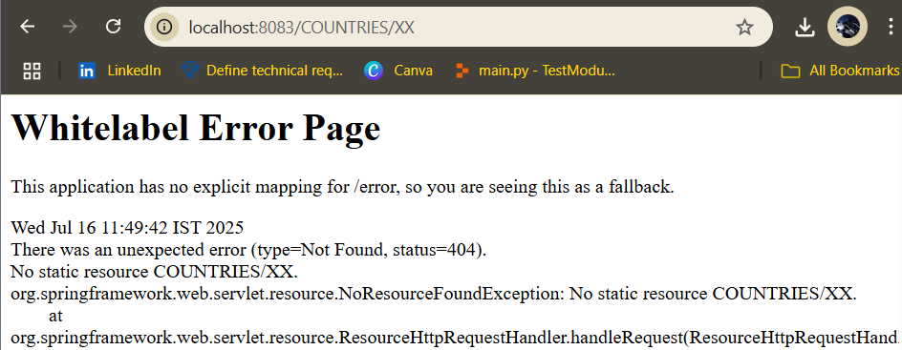

*curl -i* [*http://localhost:8083/countries/IN*](http://localhost:8083/countries/IN)

HTTP/1.1 200

Content-Type: application/json

Transfer-Encoding: chunked

Date: Wed, 16 Jul 2025 13:01:17 GMT

*curl -i http://localhost:8083/countries/xx*

HTTP/1.1 404

Content-Type: application/json

Transfer-Encoding: chunked

Date: Wed, 16 Jul 2025 13:01:24 GMT

{"timestamp":"2025-07-16T13:01:24.795+00:00","status":404,"error":"Not Found","message":"Country not found","path":"/countries/xx"}